Dear Colleagues!

The Organizing Committee herewith invites you to the Xth International scientific-practical conference “Actual Problems of Economic Development”, which will be held on October 4-5, 2019 at Belgorod State Technological University named after V.G. Shukhov.

CONFERENCE TOPICS

- Economic issues and prospects for global and regional development
- Actual problems of economic theory and practice in business functioning
- Theory and practice in management and marketing
- Topics in reforming and development of accounting, auditing, taxation and finances in Russia

REGISTRATION CARD
for participant of Xth International scientific-practical conference “Actual Problems of Economic Development”

Last Name
First Name
Second Name
Position
Academic degree
Academic title
Organization’s name

Phone
Phone mobile
E-mail
Report type
oral report

poster report

plenary report

Type of participation
(full-time / correspondence) _______________
Report name ___________________________
Conference topic
^{(put a number of topic)}
The form should be applied at Organizing Committee
until April 1, 2019 by e-mail conf@intbel.ru.
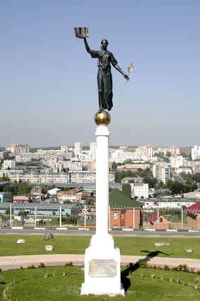

DEADLINES

April 1, 2019 – registration deadline
April 30, 2019 – submission of draft manuscripts
May 30, 2019 – second circular
September 30, 2019 – distribution of the conference program
October 4-5, 2019 – Xth International scientific-practical conference “Actual Problems of Economic Development”

LANGUAGES
Russian, English

Form of conducting: full-time / correspondence.
The conference proceedings will be assigned an international ISBN index, publication in the Russian Science Citation Index (RISC) database of the Scientific Electronic Library elibrary.ru.
The proceedings will be posted on the website and open access repositories of BSTU named after V.G. Shukhov.

LOCAL ORGANIZING COMMITTEE
Ekaterina Gokova,
Anastasiya Goryagina,
Natalia Kirillova,
Natalia Kalmykova.

CONTACTS

308012, Russia, Belgorod,
Kostyukova, 46,
BSTU named after V.G. Shukhov
Dept of Scientific and Technical Information
tel/fax: (4722) 55-17-49,
e-mail: conf@intbel.ru

Event held
with the financial support of the
Russian Foundation for Basic Research
ORGANIZING COMMITTEE
Chairman:
Sergey Glagolev, Dr. Econ Sci, prof.
Co-chairman:
Yuriy Doroshencko, Dr. Econ Sci, prof.
Chairman’s deputies:
Irina Somina, Dr. Econ Sci, prof.
Committee members:
Sergey Kupriyanov, Dr. Econ Sci, prof;
Maria Starikova, Dr. Econ Sci, prof;
Sofia Bukhonova, Dr. Econ Sci, prof;
Irina Slabinskaya, Dr. Econ Sci, prof;
Maria Seroshtan, Dr. Econ Sci, prof.

PROGRAM COMMITTEE

Chairman:
Yuriy Seliverstov, Dr. Econ Sci, prof.
Chairman’s deputies:
Anatoliy Rudychev, Dr. Econ Sci, prof.
Committee members:
Elena Chizhova, Dr. Econ Sci, prof.;
Ekaterina Schetinina, Dr. Econ Sci, prof.;
Alexander Troshin, Dr. Econ Sci, prof.;
Elena Arskaya, Cand. Econ Sci, Asc. prof.;
Tadia Jukic, prof.;
Jivota Radosavljevic, phD, prof;
Milan Radosavljevic, phD, prof.;
Maya Andjelkovic, prof.

CONFERENCE SITE
http://conf.bstu.ru/conf_bstu/aktualnie_problemi_2019

First Circular
The Ministry of Science and Higher Education of the Russian Federation
Belgorod Regional
Department of Economic Development
The Faculty of Business Studies and Law
Nikola Tesla - Union University
The Faculty of IT and Engineering
Nikola Tesla - Union University
The Faculty Of Economics
University Of Niš
Institute of Economics and Management
Belgorod State Technological University named after V.G. Shukhov

Xth International
scientific-practical conference
Actual Problems
of Economic Development
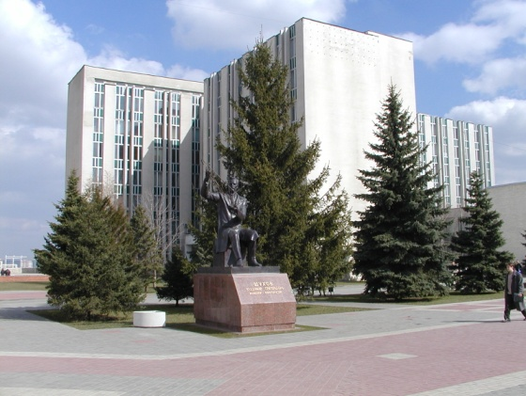

October 4-5, 2019
Belgorod, Russia

